INTERNATIONAL CYBERSECURITY AND DIGITAL FORENSICS ACADEMY
Week 4 Practical Laboratory
Linux Security Monitoring and Auditing
Audit and Control-Assurance Report
Course | GRC102 - Information Security Governance
Module | Module 4 - Monitoring and Auditing Security Controls
Student name | Diana Wanjiru
Registration number | C11/26/CGRCE/17188
Role assumed | Security Control Assurance Analyst
Assessed system | Kali Linux VM, hostname "dee" (kernel 6.18.12+kali-amd64), assigned account "cybergirlie"
Report date | 05 October 2026

1. Executive Summary
This report presents the results of a hands-on assurance review of one Linux host. The review covered system auditing (auditd), log analysis (journalctl), and a configuration assessment (Lynis 3.1.6). The evidence was then mapped to control objectives, owners, thresholds and retest actions.
Overall posture: partially effective, needs improvement. The core detective controls work. auditd is active and enabled, its five rules loaded without error, and the watch on /etc/passwd recorded attributable events (user, process, time). Privileged use through sudo is logged with user, terminal, working directory and command. The persistent journal also holds authentication events back to 28 April 2026. However, the evidence base is not yet resilient, several expected protective controls are absent, and authentication monitoring has coverage gaps.
Top three findings
- Evidence-storage risk (F01, High). smartd reported 3 currently unreadable (pending) sectors on /dev/sda at 22:34:47. Audit and journal records are stored locally and are not forwarded off-host (F02), so disk degradation could destroy the assurance trail.
- No off-host audit forwarding and an authentication coverage gap (F02 and F03, Moderate). auditd reports "No plugins found, not dispatching events". /var/log/auth.log does not exist, so the loaded auth.log audit rule watches a non-existent file. The audit window recorded zero login or authentication events.
- Weak host-protection and hardening posture (F04 to F06, Moderate). Lynis reports a hardening index of 63 out of 100 across 273 tests, with no intrusion-detection software and no malware scanner detected.
Reading note: Times are shown as recorded by the host, in EAT (UTC+3). The lab brief uses WAT (UTC+1), so WAT is EAT minus one hour. Findings are limited to evidence actually captured in this laboratory.

2. Scope and Authorisation
- Environment: the assigned Kali Linux virtual machine (hostname dee, auditd 4.1.2, Lynis 3.1.6), used as an isolated training system.
- Authorised activities: service verification, creating a dedicated audit rules file, reading logs, running a Lynis audit, and generating benign local events.
- Boundaries: no external systems or production infrastructure were targeted. No changes were saved to /etc/passwd or /etc/shadow, no logging was disabled, and no evidence was deleted. The only configuration change was the new file /etc/audit/rules.d/custom.rules.
- Distribution differences: Kali uses systemd-journald and has no /var/log/auth.log or /var/log/syslog. The journal was therefore used as the equivalent source, as the lab brief permits.
- Not performed: the optional Lynis hardening and retest (Activity 3.3) was not carried out, so no before/after evidence is claimed.

3. Methodology
Phase | Method and tools
auditd | Verified the service with systemctl status. Created custom.rules with five rules (account-file watches, execve monitoring, auth.log watch), restarted auditd and listed the rules with auditctl -l. Generated benign events, then queried them with ausearch -k and aureport (summary, --failed, --login).
Log analysis | Reviewed the journal with journalctl -f, -b, -p err and -p warning. Used journalctl _COMM=sudo and keyword searches for privilege use and failed authentication. Attempted the file-based commands on /var/log/auth.log to document that the file is absent.
Lynis | Confirmed the version with lynis show version and lynis update info. Ran lynis audit system and recorded the hardening index, tests performed, component results and report/log locations.
Governance mapping | Translated evidence into finding records (Appendix A template), a control-monitoring table, SIEM/continuous-monitoring mapping, escalation thresholds, and a remediation and retest plan.

4. Findings and Evidence

4.1 Evidence Bundle 1: auditd Configuration and Events

Service status (Activity 1.1)
auditd 4.1.2 is active (running) and enabled. The journal lines show it started at 19:51:59 EAT. The enable step created the systemd symlink (via the SysV install script), which indicates the service was not previously set to start at boot. The line "No plugins found, not dispatching events" shows no dispatcher plugin is configured, which is relevant to finding F02.
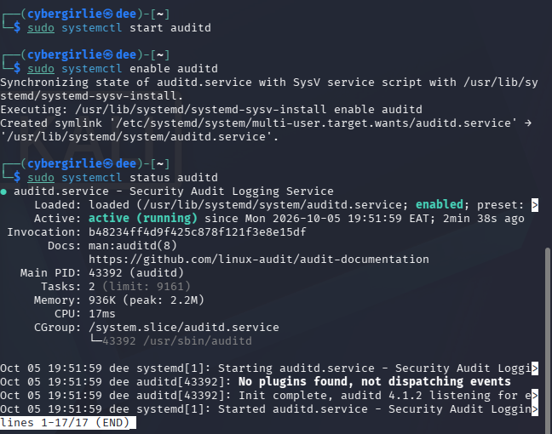
Figure 1: auditd started, enabled and confirmed active (running); main PID 43392.

Loaded audit rules (Activity 1.2)
A dedicated file, /etc/audit/rules.d/custom.rules, was created and auditd restarted with systemctl restart auditd. Five rules loaded:
Rule | Key | Purpose
-w /etc/passwd -p rwxa | passwd_changes | Account database access/changes
-w /etc/shadow -p rwxa | shadow_changes | Password hash file access/changes
-a always,exit -F arch=b64 -S execve | program_execution | Program execution (64-bit)
-a always,exit -F arch=b32 -S execve | program_execution | Program execution (32-bit)
-w /var/log/auth.log -p wa | auth_failures | Authentication log changes (see F03)
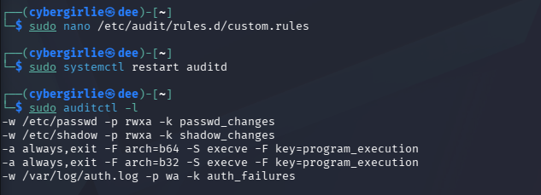
Figure 2: custom.rules created, auditd restarted, and the five loaded rules listed with auditctl -l.

Audit events by key (Activity 1.3)
passwd_changes. The query returned the rule-load record (add_rule, 20:14:00) and two file-access records at 20:14:31 EAT for /etc/passwd.
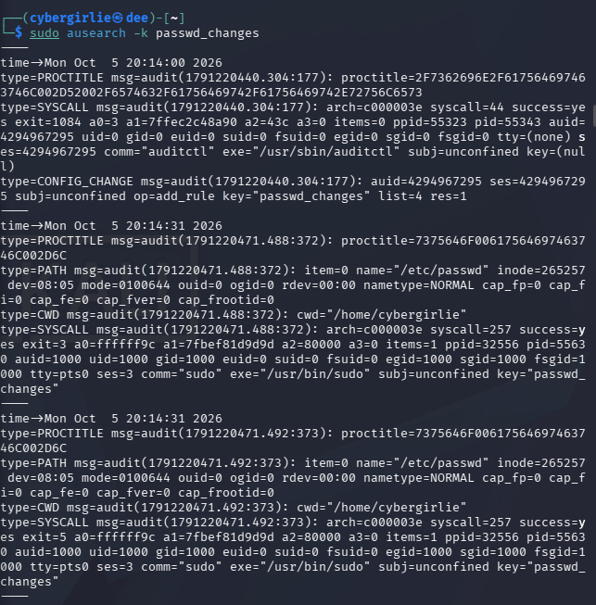
Figure 3: ausearch -k passwd_changes: rule load at 20:14:00 and two sudo accesses to /etc/passwd at 20:14:31.
program_execution. The query returned the rule-load records plus execve records. The visible execve event, at 20:14:00 and caused by the audit restart, includes /bin/sh and the dynamic loader as PATH items.
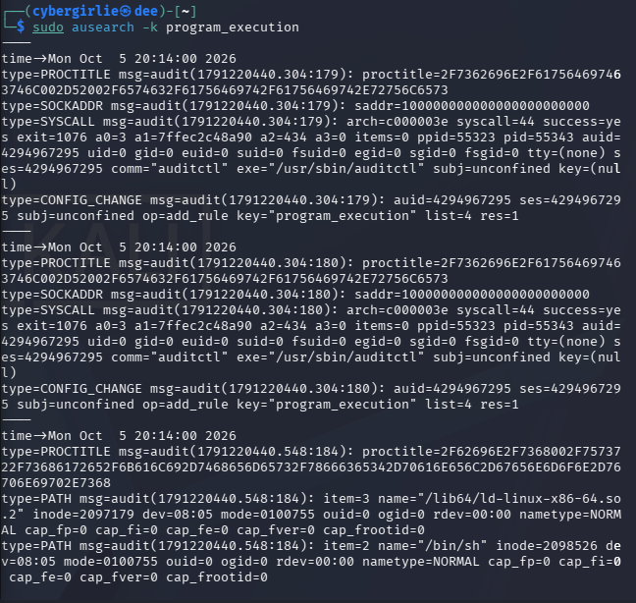
Figure 4: ausearch -k program_execution: rule loads and execve records.
auth_failures. Only the rule-load record (CONFIG_CHANGE, op=add_rule, res=1) was returned, with no authentication-log file events. The PATH item points at the parent directory /var/log/ because the watched file does not exist. This is the evidence behind finding F03.
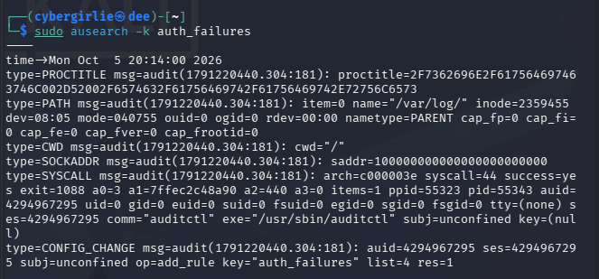
Figure 5: ausearch -k auth_failures: only the rule-load event; the watched file is absent.

Audit summary reports (Activity 1.3)
aureport metric (19:51:59.473 to 20:58:00.618) | Value
Total events / process IDs | 16,728 / 16,053
Changes in configuration | 11
Changes to accounts, groups or roles | 0
Logins / failed logins | 0 / 0
Authentications / failed authentications | 0 / 0
Distinct users / executables / commands / files | 3 / 40 / 59 / 54
Failed syscalls | 192 (227 in the later --failed report)
Anomaly events | 1
Keys matched | 4 (passwd_changes, shadow_changes, program_execution, auth_failures)

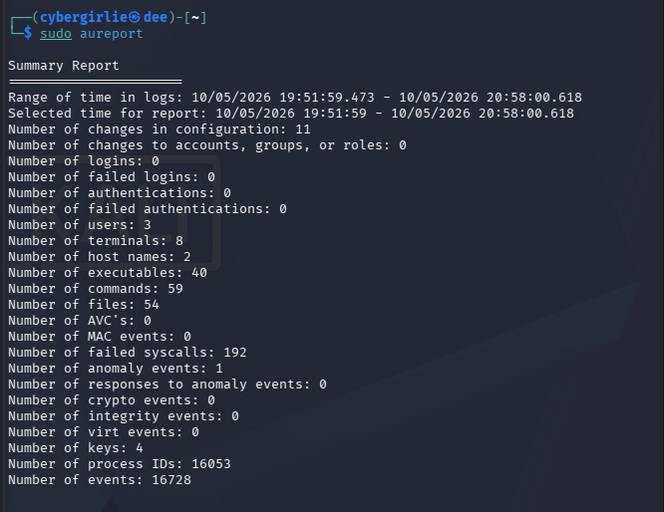
Figure 6: aureport summary report for the audit window.
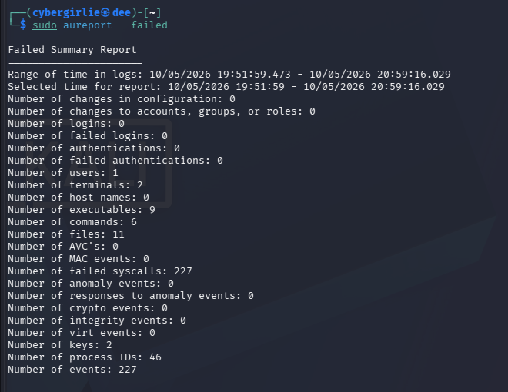
Figure 7: aureport --failed: 227 failed syscalls and 0 failed logins or authentications.
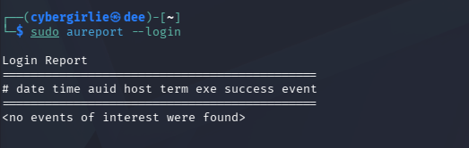
Figure 8: aureport --login: no events of interest were found.

Interpretation
Who, what, when. The record at 20:14:31 EAT shows user "cybergirlie" (auid=1000, the original login identity that persists through sudo, with uid=1000 and euid=0) running /usr/bin/sudo from /home/cybergirlie on terminal pts0 (session 3). The syscall was openat (257), success=yes, against /etc/passwd, tagged with key passwd_changes. The flags argument (a2=80000) corresponds to a read-only open with close-on-exec, so this was read access, not a modification. Two records appear (exit=3 and exit=5), which is consistent with sudo reading /etc/passwd to resolve user identity when launching a privileged command. The command line is hex-encoded in the PROCTITLE field and can be decoded with ausearch -i.
Rule-load records. The CONFIG_CHANGE records at 20:14:00 (op=add_rule, res=1) were written by /usr/sbin/auditctl with auid=4294967295, meaning no login session was attached. The rules were therefore loaded by the audit service, and each loaded successfully. This confirms that changes to audit configuration are themselves audited.
Governance relevance. The records show that account-file access is attributable to a named user, process and time, which supports accountability, detection of unauthorised account or privilege changes, and forensic reconstruction. aureport recorded 0 account changes, 0 logins and 0 authentications. The zero login count is explained by the desktop session starting before auditd (19:51:59), so the audit trail does not cover earlier activity. This is a limit on coverage, not proof that no logins occurred. The 1 anomaly event and the 192 to 227 failed syscalls were not investigated further and are recommended for triage (aureport --anomaly, aureport --syscall --failed).

4.2 Evidence Bundle 2: Linux Log Analysis

System-log review with journalctl (Activity 2.1)
Live following showed routine scheduled activity (cron jobs for phpsessionclean, sysstat and cron.hourly), the sudo session opened by cybergirlie to run journalctl -f at 21:12:10, an auditd log rotation at 21:11:20, and a systemd-timesyncd timeout contacting 2.debian.pool.ntp.org at 21:12:23 that recovered at 21:12:25. The current-boot journal begins with the Kali kernel 6.18.12+kali-amd64 record, timestamped 21:34:44, which differs from the 19:51:59 auditd start time. This is noted as a time-integrity observation to verify (journalctl --list-boots, timedatectl) rather than a confirmed fault.
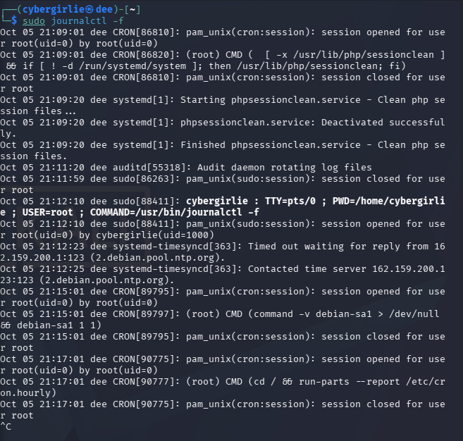
Figure 9: journalctl -f: routine cron activity, auditd log rotation, sudo session and an NTP timeout.
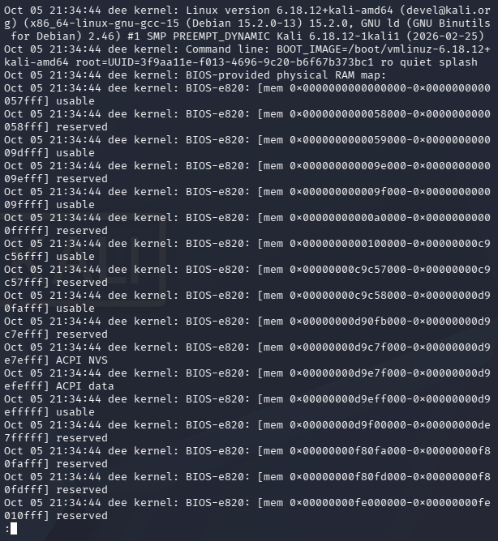
Figure 10: journalctl -b: start of the current-boot journal (kernel version and memory map).

Authentication and privilege-use analysis (Activity 2.2)
Equivalent source. /var/log/auth.log does not exist on this system ("No such file or directory"), so journalctl was used as the equivalent source.
Privilege use. journalctl _COMM=sudo shows user cybergirlie (TTY=pts/0, PWD=/home/cybergirlie, USER=root) running privileged commands: /usr/bin/less /var/log/auth.log at 21:55:36 and journalctl _COMM=sudo --no-pager at 22:07:03 and 22:12:15. Each command has a matching session opened and closed record for root, initiated by uid 1000. All activity is attributable and matches the authorised lab tasks.
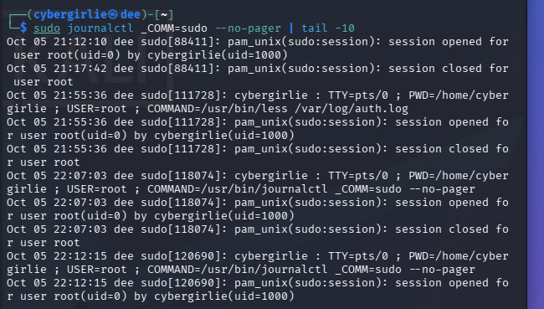
Figure 11: journalctl _COMM=sudo: attributable privileged commands by cybergirlie (uid 1000).
Failed authentication. The search for "failed password" returned no events; the only line shown is the sudo password prompt itself. The search for "authentication failure" returned at least ten historic lightdm (login screen) PAM failures on four dates: 28 April (3), 21 May (2), 22 May (3) and 23 May (2) 2026, with empty ruser and rhost fields, which indicates local console logins rather than remote attempts. The entries also show that the journal retains data back to April, consistent with persistent journal storage (to be confirmed with ls -ld /var/log/journal and journalctl --disk-usage).
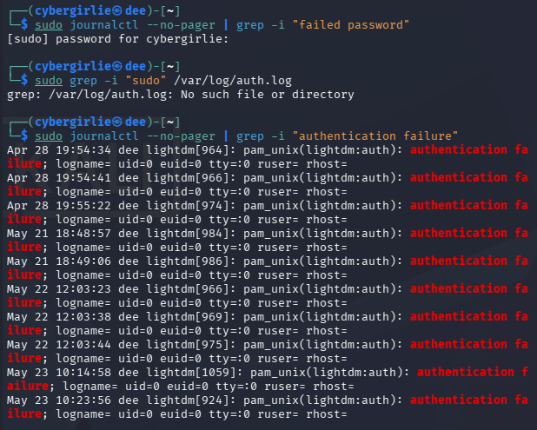
Figure 12: Failed-password search (no events), the absent auth.log, and historic lightdm authentication failures.

Error and warning review (Activity 2.3)
/var/log/syslog is not present, so journalctl -b -p err and -p warning were used. Both views end with the same entries because these messages are logged at error priority. Two are security-relevant: repeated xfce4-screensaver PAM failures ("auth could not identify password for [cybergirlie]" followed by "conversation failed") at 22:25:28, 22:26:39, 22:27:45, 22:28:50 and 22:30:24, and a smartd warning at 22:34:47 reporting 3 currently unreadable (pending) sectors on /dev/sda.
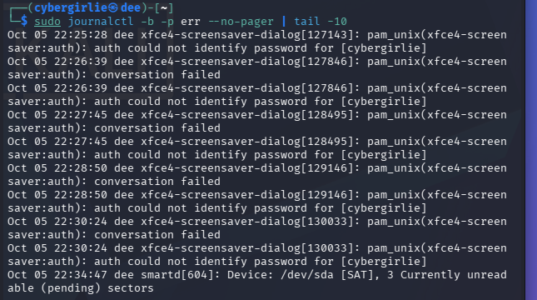
Figure 13: journalctl -b -p err: repeated screensaver PAM errors and the smartd pending-sector warning.
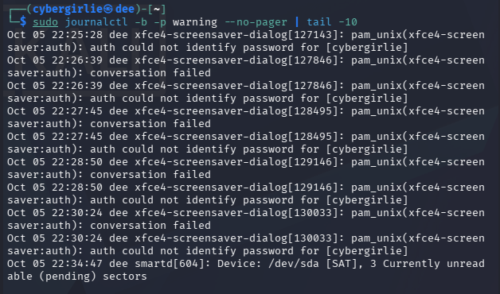
Figure 14: journalctl -b -p warning: the same entries at warning level or above.

Event table
Event / condition | Evidence source | Time (EAT) | User / service | Security significance | Recommended action
Privileged commands via sudo | journalctl _COMM=sudo | 21:55:36 to 22:12:15, 05 Oct | cybergirlie to root | Privileged use is attributable (user, tty, command). Matches authorised lab activity. | Include in periodic privileged-access review.
No auth.log; no "failed password" events | ls/grep on auth.log; journalctl grep | 05 Oct (review) | n/a | No file-based auth log. No failed-password events recorded, but coverage depends on the journal. | Document journald as authoritative; see F03.
Historic lightdm authentication failures | journalctl grep "authentication failure" | 28 Apr; 21, 22, 23 May 2026 | lightdm / PAM (local console) | Clustered local login failures on four dates. Likely mistyped credentials, but unconfirmed. | Confirm with account owner; define a failure-rate alert threshold.
Repeated screensaver PAM errors | journalctl -b -p err | 22:25:28 to 22:30:24 | xfce4-screensaver / cybergirlie | Repeated local failures on one account roughly every minute. Could be a failing unlock helper or guessing at a locked console. | Investigate; check unix_chkpwd and who was at the console.
Disk pending sectors | journalctl -b -p warning | 22:34:47 | smartd, /dev/sda | Early sign of media degradation on the disk holding logs. Threat to evidence availability. | Run smartctl -a, back up logs, plan replacement (F01).
NTP timeout (recovered) | journalctl -f | 21:12:23 to 21:12:25 | systemd-timesyncd | Time accuracy underpins audit timestamps. Brief outage only. | Monitor time-sync status; no immediate action.
Routine cron and auditd rotation | journalctl -f | 21:09 to 21:17 | cron, auditd | Normal scheduled activity and log rotation. | No action.

4.3 Evidence Bundle 3: Lynis Security Assessment
The installed Lynis version is 3.1.6 (released 2025-10-22), and lynis update info reports its status as up-to-date, so the package meets the "current stable release" expectation.
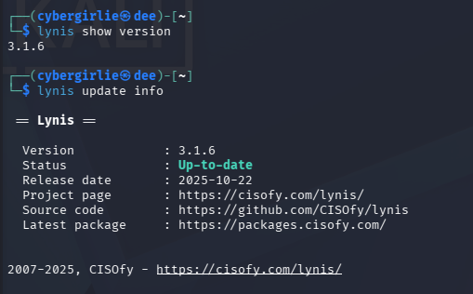
Figure 15: lynis show version and lynis update info: Lynis 3.1.6, up-to-date.
Lynis result | Value
Scan mode / modules | Normal; Security audit [V]; Vulnerability scan [V]; Compliance status [?]
Hardening index | 63 out of 100
Tests performed / plugins enabled | 273 / 1
Firewall | [V] detected
Intrusion software | [X] not detected
Malware scanner | [X] not detected
Report and log locations | /var/log/lynis-report.dat and /var/log/lynis.log

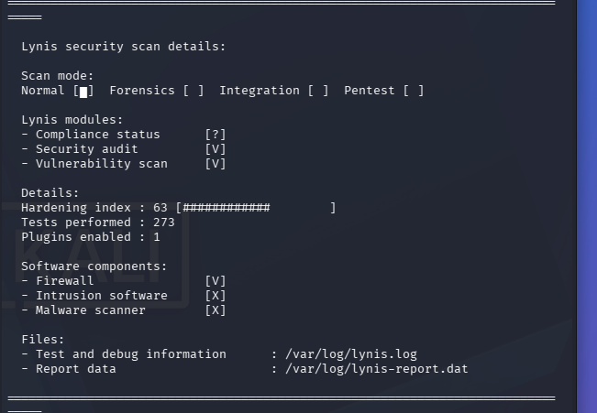
Figure 16: Lynis system audit summary: hardening index 63, 273 tests, no intrusion software or malware scanner.

Prioritised findings from Lynis
ID | Finding and evidence | Risk / control issue | Likely owner | Priority | Remediation
F04 | No intrusion software detected (Lynis summary: Intrusion software [X]) | No host-level detection of malicious or abnormal activity | Security Operations | Moderate | Deploy an approved HIDS, fail2ban or EDR agent
F05 | No malware scanner detected (Lynis summary: Malware scanner [X]) | Malicious code could go unnoticed | Endpoint security / sysadmin | Moderate | Install an approved scanner with scheduled scans
F06 | Hardening index 63 of 100 across 273 tests | Configuration baseline below a proposed target of 80, so weaknesses are likely unremediated | Infrastructure / Linux sysadmin | Moderate | Triage warnings and suggestions by test ID, fix high-value items, document accepted risks

Optional retest (Activity 3.3): not performed, so there is no before/after evidence in this report.

4.4 Finding Records (Appendix A format)
W4-F01: Disk reliability warning on the host holding audit and log evidence
Date / Time Observed | 05 Oct 2026, 22:34:47 EAT (21:34:47 WAT)
Evidence Source | journalctl -b -p err/warning (smartd[604])
Evidence Summary | smartd: "Device: /dev/sda [SAT], 3 Currently unreadable (pending) sectors".
Security Significance | Pending sectors are an early indicator of media failure. Audit and journal records are stored locally and not forwarded (F02), so a failing disk could make evidence unavailable or corrupted.
Control Objective | Audit and log records remain complete, intact and recoverable for the retention period.
Control Owner | Linux System Administrator / Infrastructure (evidence owner: Security Operations)
Risk / Priority | High: threatens the evidence base for several other controls.
Recommended Action | Run smartctl -a /dev/sda; back up logs now; forward logs off-host; replace or migrate the disk if the count rises.
Retest Evidence | smartctl report with 0 pending sectors or evidence of replacement; no new smartd warnings over 30 days; a successful log restore test.

W4-F02: Audit events are not forwarded off-host
Date / Time Observed | 05 Oct 2026, 19:51:59 EAT
Evidence Source | systemctl status auditd (journal lines)
Evidence Summary | "No plugins found, not dispatching events".
Security Significance | Audit evidence exists only on the local disk. It cannot be correlated centrally and could be altered or lost by an attacker with root access or by disk failure.
Control Objective | Audit evidence is centrally collected, tamper-resistant and monitored.
Control Owner | Security Operations (SIEM) with the Linux System Administrator
Risk / Priority | Moderate (High if the host is a business-critical production system).
Recommended Action | Configure an approved forwarding method (audit remote/dispatcher plugin or agent/rsyslog) to the SIEM.
Retest Evidence | A test audit event on the host appears in the SIEM within the agreed delay (for example 5 minutes); status output no longer reports that no plugins were found.

W4-F03: Authentication log coverage gap (no auth.log; rule watches a missing file)
Date / Time Observed | Rule loaded 05 Oct 2026, 20:14:00 EAT; absence confirmed during Module 2 review
Evidence Source | auditctl -l; ausearch -k auth_failures; aureport --login; grep on /var/log/auth.log
Evidence Summary | The auth_failures rule is loaded but /var/log/auth.log does not exist. The key returned only the rule-load record, and aureport showed 0 logins and 0 authentications in the audit window. Authentication evidence exists only in the journal (lightdm, sudo, PAM entries).
Security Significance | The control gives a false impression of authentication monitoring. Effective detection depends on journal retention and on audit coverage, which began only at 19:51:59.
Control Objective | Authentication and privileged-use events are captured, retained and reviewable.
Control Owner | Linux System Administrator; Security Operations
Risk / Priority | Moderate
Recommended Action | Document journald as the authoritative source (or install rsyslog if a file log is required). Replace the rule with audit monitoring of authentication events (aureport --auth) and journal forwarding. Confirm the journal is persistent.
Retest Evidence | A deliberate failed local sudo attempt appears in the journal, in aureport --auth --failed, and in the SIEM.

W4-F04: No intrusion detection or prevention software (Lynis)
Date / Time Observed | Lynis scan, 05 Oct 2026 (time not captured in the screenshot)
Evidence Source | Lynis summary screen
Evidence Summary | Software components: Intrusion software [X].
Security Significance | No host-based capability to detect or block malicious behaviour such as brute-force logins or file tampering.
Control Objective | Suspicious host activity is detected and alerted on.
Control Owner | Security Operations
Risk / Priority | Moderate
Recommended Action | Deploy an approved HIDS, fail2ban or EDR agent, integrated with SIEM alerting.
Retest Evidence | Lynis shows Intrusion software [V]; a test detection raises an alert.

W4-F05: No malware scanner (Lynis)
Date / Time Observed | Lynis scan, 05 Oct 2026 (time not captured in the screenshot)
Evidence Source | Lynis summary screen
Evidence Summary | Software components: Malware scanner [X].
Security Significance | Malicious code or tools could run undetected on a business-critical host.
Control Objective | Malware is prevented or detected through scanning.
Control Owner | Endpoint security team / Linux System Administrator
Risk / Priority | Moderate
Recommended Action | Install an approved scanner (or enterprise EDR) with scheduled scans and signature updates.
Retest Evidence | Lynis shows Malware scanner [V]; scheduled scan logs and a clean test (for example EICAR) detection.

W4-F06: Hardening index of 63 out of 100
Date / Time Observed | Lynis scan, 05 Oct 2026 (time not captured in the screenshot)
Evidence Source | Lynis (report data /var/log/lynis-report.dat)
Evidence Summary | Hardening index 63; 273 tests performed; 1 plugin enabled.
Security Significance | A mid-range score indicates configuration weaknesses that increase attack surface. The index is only meaningful alongside its specific warnings and suggestions.
Control Objective | Systems conform to an approved hardening baseline.
Control Owner | Infrastructure / Linux System Administrator
Risk / Priority | Moderate
Recommended Action | Triage warnings and suggestions by test ID. Remediate those with clear risk and low operational impact, and record formal risk acceptance for the rest.
Retest Evidence | Re-run Lynis after changes and compare the hardening index and the warning list; trend over successive quarterly scans.

W4-F07: Repeated local authentication failures
Date / Time Observed | Historic: 28 Apr, 21-23 May 2026. Current: 05 Oct 2026, 22:25:28 to 22:30:24 EAT
Evidence Source | journalctl grep "authentication failure"; journalctl -b -p err
Evidence Summary | At least ten lightdm PAM failures on four dates, plus screensaver PAM errors ("auth could not identify password for [cybergirlie]", "conversation failed") at roughly one-minute intervals.
Security Significance | Repeated failures on one account can indicate password guessing. The pattern here (local, regular interval, no remote host) suggests a helper or configuration problem or user error, but this cannot be confirmed from the evidence alone.
Control Objective | Failed authentication is monitored, thresholds trigger alerts, and anomalies are investigated.
Control Owner | Linux System Administrator; Security Operations
Risk / Priority | Low (pending investigation); escalate if the cause is unexplained or the pattern recurs.
Recommended Action | Check journalctl -b | grep xfce4-screensaver and the permissions of unix_chkpwd; confirm with the user whether the locked screen was being unlocked.
Retest Evidence | Screen unlock works; no repeated PAM errors over 7 days; failure-rate alert rule present in the SIEM.

5. Control-Monitoring Table
Thresholds marked "proposed" are suggested for management approval and are not existing organisational policy. Rows C1, C2, C3, C4, C5, C7 and C9 are based directly on evidence collected in this laboratory.
Control / objective | Evidence | Owner | Observed status | KPI / KRI or threshold | Risk / significance | Remediation | Retest / follow-up
C1. System auditing active (auditd) - provide an audit trail for accountability | auditd 4.1.2 active and enabled; 5 rules loaded; 16,728 events in the window (Figs 1, 2, 6) | Linux sysadmin / Security Operations | Operating (enabled during this lab) | KPI: 100% of in-scope hosts with auditd active and baseline rules loaded. KRI: any host without auditd for more than 24 h (proposed) | Without auditing there is no reliable user/action evidence | Deploy the rule baseline through configuration management; consider locked rules after validation | Monthly automated check: systemctl is-active auditd and auditctl -l compared with the baseline
C2. Audit evidence forwarded off-host - tamper-resistant central evidence | auditd: "No plugins found, not dispatching events" (Fig 1) | Security Operations (SIEM) | Gap | KPI: % of hosts forwarding audit logs (target 100%, proposed). Delivery delay of 5 minutes or less | Local-only evidence can be altered or lost; no central correlation | Configure the audit dispatcher or agent to forward to the SIEM | Send a test event; confirm it appears in the SIEM; repeat quarterly
C3. Authentication monitoring - failed and successful logins captured and reviewed | No auth.log; auth_failures rule watches a missing file; aureport shows 0 logins; journal has lightdm and screensaver PAM failures (Figs 5, 8, 12, 13) | Linux sysadmin / Security Operations | Partially effective | Alert: 5 or more failed logins per account in 10 minutes (proposed). KPI: % of authentication events visible centrally | Authentication abuse could be missed or detected late | Use the journal or rsyslog as the source, replace the auth.log rule with audit authentication records, forward to the SIEM | Generate a controlled failed local attempt; verify it in the journal, aureport and the SIEM
C4. Privileged-access monitoring - privileged use is attributable and reviewed | journalctl _COMM=sudo shows user, TTY, PWD, USER=root and command for each use (Fig 11) | Linux sysadmin / IAM lead | Operating | KPI: 100% of sudo events attributable and reviewed within 7 days (proposed). KRI: any unexplained sudo to root | Privileged misuse could go unnoticed without review | Schedule review of sudo events; forward them to the SIEM with alerting on anomalies | Weekly review sample; monthly report of privileged activity
C5. Account-file integrity - unauthorised changes to /etc/passwd and /etc/shadow are detected | passwd_changes and shadow_changes watches loaded; two read-only sudo accesses to /etc/passwd; 0 account changes in aureport (Figs 2, 3, 6) | System owner / Security Operations | Operating | KRI: unauthorised writes to /etc/passwd or /etc/shadow = 0; any occurrence is escalated | Account tampering enables persistence and privilege escalation | Alert in the SIEM on write or attribute events for these keys | Controlled benign write test in the lab, confirmed in ausearch; quarterly
C6. Log retention and time integrity - records retained and timestamps reliable | Journal entries back to 28 Apr 2026 (Fig 12); NTP timeout 21:12:23, recovered 21:12:25 (Fig 9); boot timestamp 21:34:44 differs from the 19:51:59 auditd start (Fig 10) | Linux sysadmin | Operating; verification pending | KPI: journal retention meets the policy period (for example 90 days, proposed). KRI: time offset or sync failures | Unreliable time or lost logs weaken forensic evidence | Confirm persistent journal and size limits; monitor timesyncd status; verify the clock and boot history | Check journalctl --disk-usage and timedatectl quarterly
C7. Configuration hardening baseline (Lynis) | Hardening index 63; 273 tests; 1 plugin (Fig 16) | Infrastructure / Linux sysadmin | Needs improvement | KPI: index at or above 80 (proposed). KRI: warnings open for more than 30 days | Weak configuration increases the attack surface | Triage and remediate by test ID; record accepted risks | Re-run Lynis quarterly and after major changes; trend the index
C8. Host protection - intrusion detection and malware scanning | Lynis: Intrusion software [X]; Malware scanner [X] (Fig 16) | Security Operations / Endpoint security | Gap | KPI: % of hosts with approved HIDS/EDR and malware scanning (target 100%, proposed) | Malicious activity may go undetected | Deploy approved tools and integrate them with the SIEM | Lynis re-scan shows [V] for both; detection test
C9. Evidence storage reliability - log storage remains healthy | smartd: 3 currently unreadable (pending) sectors on /dev/sda at 22:34:47 (Figs 13, 14) | Infrastructure / Linux sysadmin | Needs action | KRI: pending or reallocated sectors greater than 0 and rising on two consecutive checks (proposed); escalate on any rise | Disk failure could destroy the audit and journal evidence | Run smartctl -a; back up and forward logs; plan replacement | smartctl report in 14 days; restore test of backed-up logs

6. SIEM and Continuous Monitoring Mapping
Host evidence would flow from the Linux host, through a collector, into the SIEM for parsing, correlation, alerting and reporting:
Linux host (auditd, journald, Lynis, smartd) > agent or forwarder (audit dispatcher, rsyslog, Filebeat/Wazuh-type agent) > SIEM (normalise, correlate, alert) > SOC alerts (operational) and dashboards/reports (governance) > ticket and workflow tracking of findings through retest.
Evidence source | Forwarding / representation | Normalised in SIEM as | Remains a technical operational alert | Becomes a governance / control-assurance issue
auditd (keys passwd_changes, shadow_changes, program_execution) | Audit dispatcher plugin or agent shipping audit.log | Audit events with user (auid), process, file, key, result | A write to /etc/shadow; an unexpected execve by a privileged user | Audit service stopped or rules cleared; audit forwarding failing for more than 24 h (control failure, F02)
journald: sudo and PAM authentication | rsyslog or journal forwarder, or agent | Authentication and privilege-use events by user and host | Repeated failed logins on one account; sudo by an unusual user | Persistent logging gaps (F03); recurring failures not investigated within SLA; review of privileged access not performed
journald: errors and warnings (smartd, timesyncd) | Journal forwarding with severity preserved | System-health events by severity | A single disk or time-sync warning triggers an investigation ticket | Rising pending-sector counts or repeated sync failures across hosts (F01, C6)
Lynis report (lynis-report.dat) | Scheduled scan; export parsed to JSON and ingested by the SIEM or GRC tool | Hardening index, warnings and suggestions by test ID, with trend | A new critical warning on a production host | Index below target for two cycles; warnings older than SLA; missing IDS or malware tooling (F04 to F06)

Automation opportunities. Continuous control monitoring can verify daily that auditd is active and its rules match the baseline. Automated alerting covers thresholds such as 5 failed logins in 10 minutes. Automated reporting can produce a monthly hardening-index trend. Workflow automation can open, assign and escalate remediation tickets for findings F01 to F07 until retest evidence is attached.

7. Governance Escalation Assessment
Highest-priority finding. F01 (disk pending sectors) is the highest priority. The assurance process relies on the audit and journal evidence stored on that disk, and F02 means there is no second copy. If the disk fails, the evidence for every other control is lost, and the failure would be silent until the records were needed.
Remediation owners. Infrastructure and the Linux System Administrator own F01 and F06. Security Operations own F02, F04 and F05, with the Linux System Administrator on F03. Endpoint security supports F05. Control assurance (GRC) owns tracking and retest.
Escalation thresholds (proposed for management approval).
- To the CISO: any unauthorised write to /etc/passwd or /etc/shadow; auditd stopped or rules cleared on an in-scope host; audit forwarding failing for more than 24 hours; SMART pending or reallocated sectors rising on consecutive checks; any High finding unremediated beyond 14 days.
- To the Risk function: hardening index below target for two consecutive cycles; Moderate findings open beyond 30 days; missing protective tooling (IDS, malware scanning) on business-critical hosts.
- To the management committee: a control that fails retest twice, findings overdue by more than twice their SLA, or any evidence of compromise or evidence loss.
Evidence of successful remediation. Re-run command output, screenshots or SIEM records showing the corrected state, for example a clean smartctl report or replaced disk, a test event arriving in the SIEM, Lynis showing [V] for intrusion software and malware scanner, and a higher hardening index with the warning list reduced.
Retest timing and method. High findings are retested within 14 days of the fix, and Moderate findings within 30 days, by repeating the same commands that produced the original evidence. Ongoing assurance runs through automated daily service and rule checks, weekly review of privileged activity, and a quarterly Lynis scan with trend comparison.

8. Remediation and Retest Plan
ID | Action | Owner | Priority | Retest evidence and timing
F01 | Check disk health with smartctl, back up logs, plan replacement | Infrastructure / sysadmin | High (14 days) | smartctl report; log restore test; 30 days with no new warnings
F02 | Configure audit forwarding to the SIEM | Security Operations | Moderate (30 days) | Test event visible in the SIEM within the agreed delay
F03 | Document the journald source; replace the auth.log rule; confirm journal persistence | Linux sysadmin / Security Operations | Moderate (30 days) | Failed attempt visible in the journal, aureport and the SIEM
F04 | Deploy an approved HIDS, fail2ban or EDR agent | Security Operations | Moderate (30 days) | Lynis shows [V]; test detection alert
F05 | Install an approved malware scanner | Endpoint security / sysadmin | Moderate (30 days) | Lynis shows [V]; scan log; test file detection
F06 | Triage Lynis warnings and suggestions and remediate by risk | Infrastructure / sysadmin | Moderate (30 days, then quarterly) | Lynis re-run; index and warning count compared
F07 | Investigate the PAM and screensaver failures | Linux sysadmin / Security Operations | Low (14 days) | No repeated PAM errors over 7 days; alert rule in place

9. Conclusion
The host has functioning foundations for security monitoring: auditd is active, its rules loaded and generate attributable records, and privileged use and authentication events are logged in a retained journal. The assurance weaknesses lie in resilience and coverage. The evidence is stored locally on a disk reporting pending sectors and is not forwarded, authentication monitoring does not rely on a usable auth.log, and Lynis reports no intrusion detection or malware scanning and a hardening index of 63. Addressing F01 and F02 first would secure the evidence base. The remaining findings can then be tracked to closure through the retest plan and the thresholds proposed above.

Appendix: Evidence Index
All screenshots are embedded in Section 4. This index lists each figure with the command that produced it.
Figure | Command / activity | What it shows | Source file
1 | systemctl start, enable, status auditd | auditd active and enabled | Activity1_1.png
2 | nano custom.rules; restart auditd; auditctl -l | Five loaded audit rules | Activity1_2.png
3 | ausearch -k passwd_changes | Rule load and /etc/passwd access records | Activity1_3a.png
4 | ausearch -k program_execution | Rule load and execve records | Activity1_3b.png
5 | ausearch -k auth_failures | Rule load only; file absent | Activity1_3c.png
6 | aureport | Summary of 16,728 events | Activity_1_3d.png
7 | aureport --failed | Failed events summary | Activity1_3e.png
8 | aureport --login | No login events | Activity1_3f.png
9 | journalctl -f | Live journal: cron, rotation, sudo, NTP | Activity2_1.png
10 | journalctl -b | Current-boot journal start | Activity2_3a.png
11 | journalctl _COMM=sudo | Privileged use by cybergirlie | Activity2_2a.png
12 | journalctl grep; grep on auth.log | No failed password; auth.log absent; lightdm failures | Activity2_2b.png
13 | journalctl -b -p err | Screensaver PAM errors; smartd warning | Activity2_3b.png
14 | journalctl -b -p warning | Same entries at warning level or above | Activity2_3c.png
15 | lynis show version; lynis update info | Lynis 3.1.6, up-to-date | Activity3_1.png
16 | lynis audit system (summary screen) | Hardening index 63; 273 tests | Activity3_2a.png

